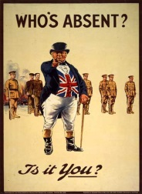
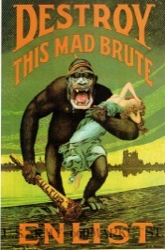
Propaganda in World War One
What is propaganda?

Propaganda is a specific type of message aimed at serving an agenda.

In the case of WWI, the Canadian government used propaganda posters to spread particular ideas or points of view to citizens of Canada.
- Remember WWI was a TOTAL WAR. This means that everyone was expected to contribute, not only the soldiers fighting overseas.
- During WWI people at home were encouraged to support the war effort. Posters and government campaigns suggested that sacrifice at home was needed to ensure a victory in Europe
- Each of the nations that participated in WWI used propaganda posters to support the war effort

They used posters to:

-Recruit men
-Justify their involvement to their people
-Raise money to fund the military campaign (Victory Bonds & Patriotic Fund)
-Encourage people to conserve resources and participate on the home front

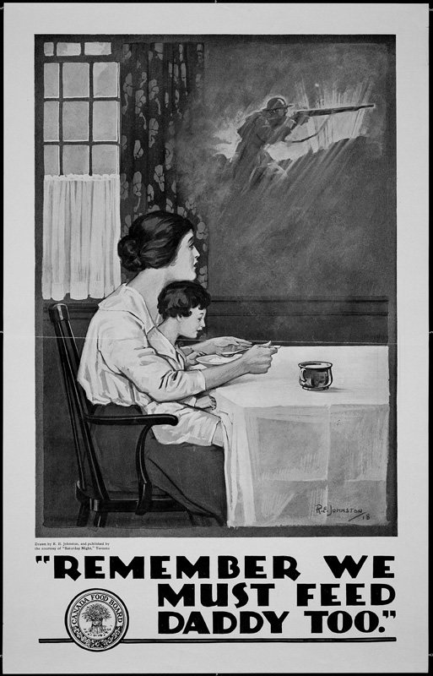
Why posters?
- Television had not yet been invented
- Not everyone owned or had access to a radio
- Posters were the most effective means of getting a message across
*These posters were posted on billboards, store windows, factory walls, and anywhere else where people gathered.

Like advertisements today propaganda uses certain techniques to get a message across effectively:
- Name Calling: Attacks people or groups to discredit their ideas. Negative words and/or images are used to create an unfavorable opinion of the competition in the viewer's mind

- Card stacking: Gaining support by using only those details that support the favoured agenda, omitting any information that may negatively affect the cause

- Bandwagon: This technique persuades the audience to “follow the crowd.” This device creates the impression of widespread support. It reinforces the human desire to be on the winning side.

- Testimonial: Propagandists use this technique to associate a respected person or someone with experience to endorse a product or cause by giving it their stamp of approval hoping that the intended audience will follow their example.

- Plain folks: This approach is used to convince the audience that the spokesperson is from humble origins, someone they can trust and who has their interests at heart.

- Transfer: A technique used to carry over the authority and approval of something we respect and revere to something the propagandist would have us accept. Propagandists often employ symbols (e.g., waving the flag) to stir our emotions and win our approval.

- Glittering Generality: Vague, sweeping statements (often slogans or simple catchphrases) using language associated with values and beliefs deeply held by the audience without providing supporting information or reason. They appeal to such notions as honor, glory, love of country, desire for peace, freedom, and family values.

Some common themes found in WWI propaganda relate to:
- Nationalism  - Adventure  - Duty | - Fear Mongering  - Guilt/ Shame  - Sacrifice

Nationalism:
- The idea that love of one’s country means fighting
- Encouraging people to fight for the nation and build solidarity with people within the nation

Adventure:
- The message that “fun” can be had while fighting overseas and discovering new lands
- War is a glorious thing and young men will become heroes

Duty:
- The expectation that men should join the “good fight” to protect their family, friends, and way of life and everyone else contribute however they can
- Man’s duty: prepare for war and focus on victory!

- Woman’s duty: pressure husband into enlisting, ration, write letters, work in munitions factories, knit for soldiers

Fear Mongering:
- The idea that terrible things will happen if the evil enemy succeeds
- Creating an “us vs. them” mentality
- Creating distrust/ Perpetuating hatred
- Encouraging secrecy (you never know who is helping the enemy, so shhhh!)

Guilt/shame:
- The idea that it was wrong to remain safe at home while other “real men” were fighting for you and your country

Sacrifice:
- Rationing- People were encouraged to eat less and waste nothing
- Industry- Scrap metal was collected, factories began producing war supplies and armaments
- Money- People were pressured to buy Victory Bonds and donate the Patriotic Fund
- Soldiers of the Soil- Helped farmers to produce food to send overseas

